4.1 Hands On Exploration: Balloons and Static Electricity (Remote Lab)

Balloons and Static Electricity and John Travoltage Remote lab ‌
(This‌ ‌lesson‌ is designed ‌for‌ ‌a‌ ‌student‌ ‌working‌ remotely‌.)‌

This lab uses the Balloons and Static Electricity and John Travoltage Remote lab simulation from PhET Interactive Simulations at University of Colorado Boulder, under the CC-BY 4.0 license.
https://phet.colorado.edu/sims/html/balloons-and-static-electricity/latest/balloons-and-static-electricity_en.html
https://phet.colorado.edu/sims/html/john-travoltage/latest/john-travoltage_en.html

Learning Goals: Students will be able to describe and draw models for common static electricity concepts. (transfer of charge, induction, attraction, repulsion, and grounding)

Develop your understanding:
- Open Balloons and Static Electricity, then explore to develop your own ideas about electrical charge.
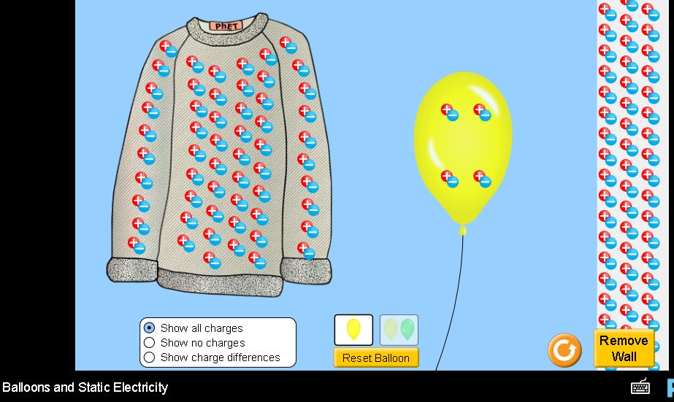

2. Open John Travoltage , then explore to develop your own ideas about electrical charge.
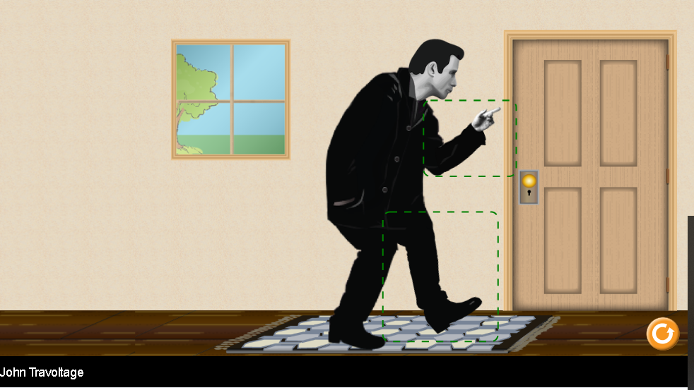

Test your understanding: Without using the simulations, predict the answers to these questions, then use the simulation to check your ideas.

Question 1 When the balloon is rubbed on the sweater, what might happen?

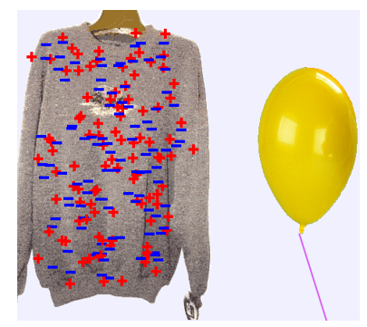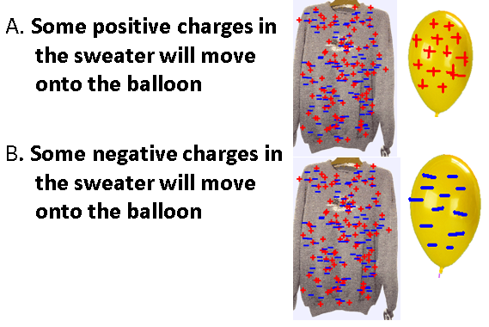

What do you predict for the answer?
Describe an experiment and include images from the simulation that supports your answer.

When the balloon is rubbed on the sweater, Negative charges are transferred to the balloon only living the positive charges on the sweater. When the balloon is released it gets attracted to the sweater.

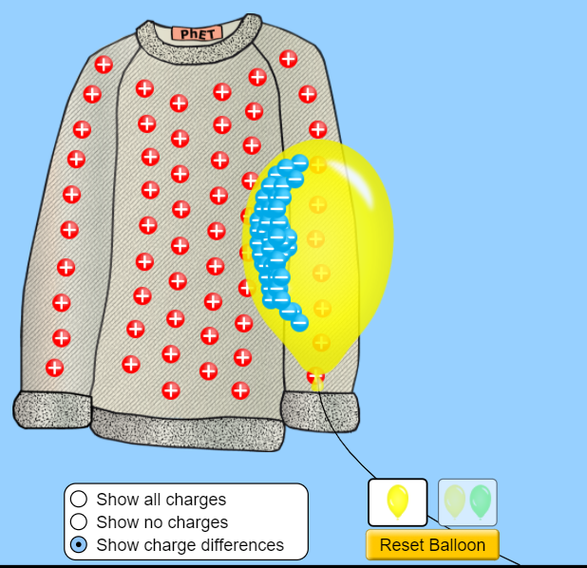
Question 2 What do you think will happen when the balloon is moved closer to the wall?
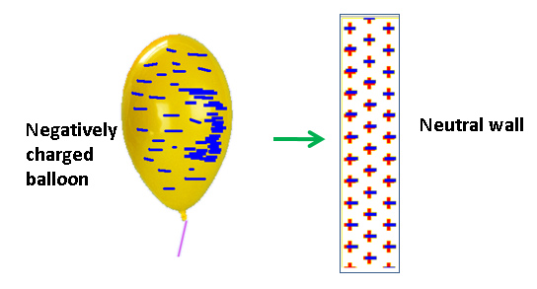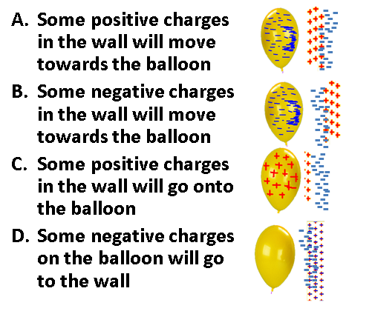

What do you predict for the answer?
Describe an experiment and include images from the simulation that supports your answer.

When The balloon is moved towards the wall, Negative charges in the wall will be repelled by the negative charges in the balloon, hence leaving positive charges which will move toward the balloon since unlike charges attract.
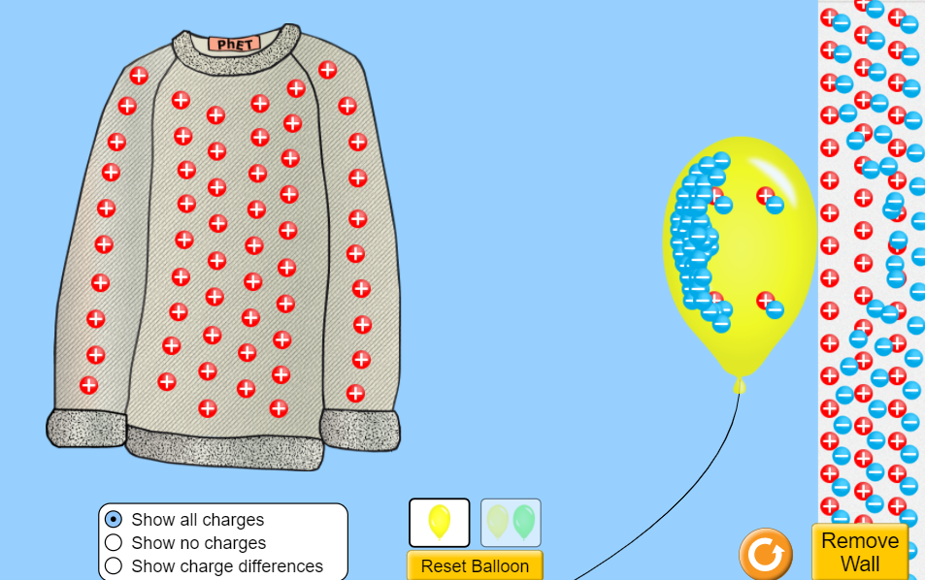
Question 3 What do you think the balloons will do?
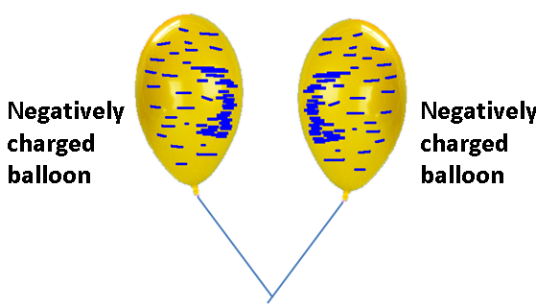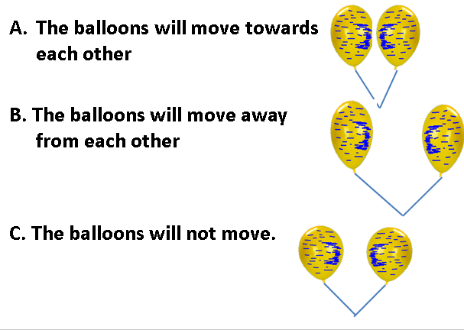

What do you predict for the answer?
Describe an experiment and include images from the simulation that supports your answer.

The balloon will move away from each other since similar charges repel.

